//Appendix

1. Block Structure – server edition

|  |  |  |
| --- | --- | --- |
| Variable Name | Data type | Description |
| Index | Integer | It is the pointer of the linear list that indicate the position of the block in the blockchain |
| User | String | It will store the username of the user who post the comment. (unique as identifier) |
| Prev hash | String | It stores the hash of previous block to make sure the block insert of both server and client are the same position |
| Detail | Content | This link to the content object |
| hash | string | The hash of the block itself – for validation |

1. Transaction (detail) structure – server edition

|  |  |  |
| --- | --- | --- |
| Variable Name | Data type | Description |
| Timestamp | Datetime | The date and time user create |
| Comment | String | The comment content |
| Ip | String | The IP address of the user |
| browser_agent | string | The browser agent of the comment creator as a reference |
| Email | String | For the user who doesn’t logged in, for further contact |

1. Gantt timeline graph

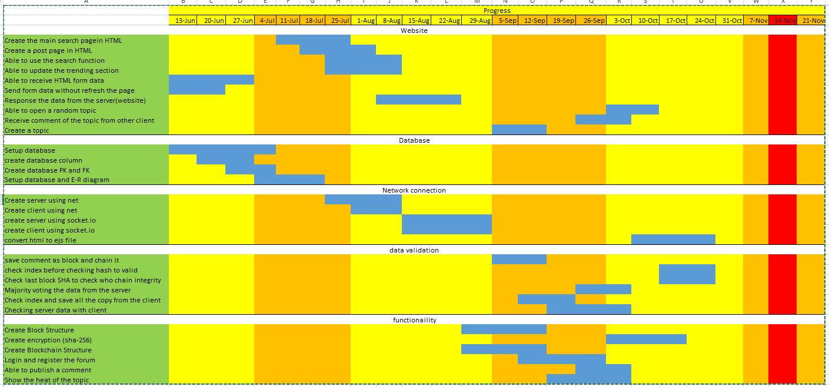

1. Block Structure – client edition

|  |  |  |
| --- | --- | --- |
| Variable Name | Data type | Description |
| Index | Integer | It is the pointer of the linear list that indicate the position of the block in the blockchain |
| User | String | It will store the username of the user who post the comment. (unique as identifier) |
| Prev hash | String | It stores the hash of previous block to make sure the block insert of both server and client are the same position |
| Detail | Content | This link to the content object |

1. Transaction structure – client edition

|  |  |  |
| --- | --- | --- |
| Variable Name | Data type | Description |
| Timestamp | Datetime | The date and time user create |
| Comment | String | The comment content |
| Ip | String | The IP address of the user |
| browser_agent | string | The browser agent of the comment creator as a reference |

1. The IP addresses of website visited

1. Survey

The rating you would give to the forum [21 response]

1. Main page

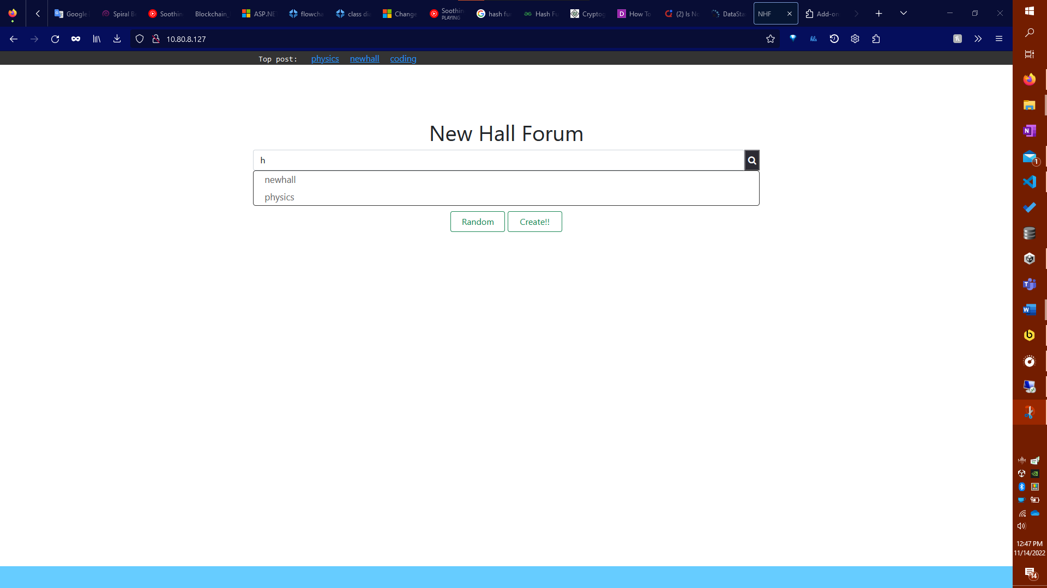

1. Discussion page

1. Login Pop-up

